Cthulhu Mythos style Side-scrolling Game

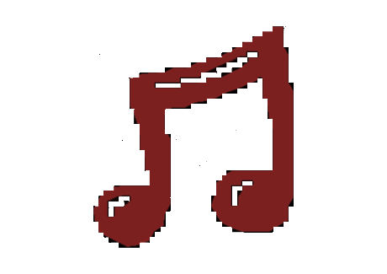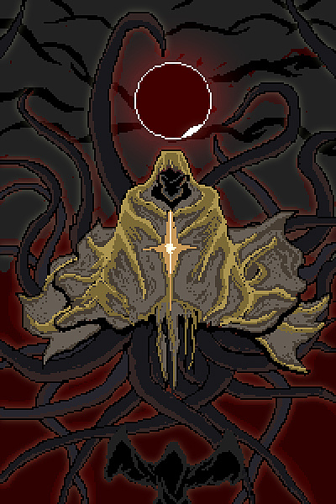

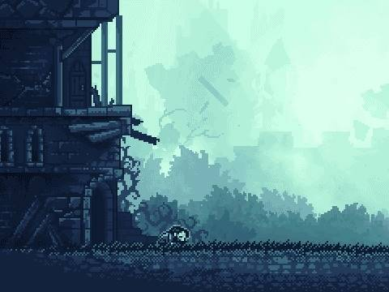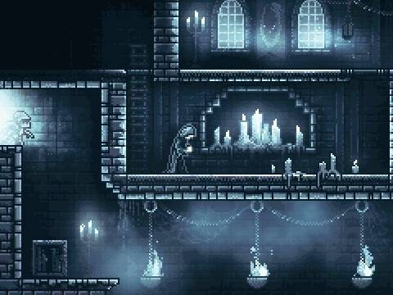Game Style (Early 19th century, Dark, Grey)

Side-scrolling + Rhythm Game

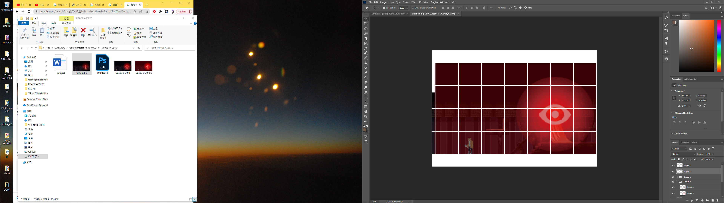

Move or jump with the beat, avoid facing the enemy when it is using its power

Using ←、↑、→ to control the character, you can only move your character on the beat, and the character move between grids.

The character will face the direction he is moving, in other words if you press “←” , the character will turn to the left and move one grid to the left.

When the character jumps, it will face his original horizontal direction.

Ex: on the following page, it takes three beats for enemy to attack, and it will launch the attack on the third beat.

